Computer Language Diagrams

Object Reference in a Diagram
The principle of object references is explained in the article Object Reference. This article demonstrates its expression in a diagram.

When a sub-object is actually an object reference, pointing to an object elsewhere in the system, then the symbol representing the sub-object will get a line, that is connected to the symbol representing the actual object, which usually resides outside the parent object.

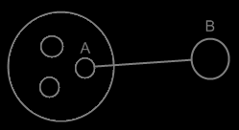

The sub-object A is an object reference to object B. Object references usually point outwards, out of an object.

See also: Object Reference, Sub-object in a diagram

Author & Copyright: Jan-Joost van Zon Date: May 22, 2008 – May 23, 2008 Location: Oosterhout, The Netherlands Status: Finished

